**TRANSIT GATEWAY**

A transit gateway is a network transit hub that you can use to interconnect your virtual private clouds (VPCs) and on-premises networks. As your cloud infrastructure expands globally, inter-Region peering connects transit gateways together using the AWS Global Infrastructure. All network traffic between AWS data centers is automatically encrypted at the physical layer.

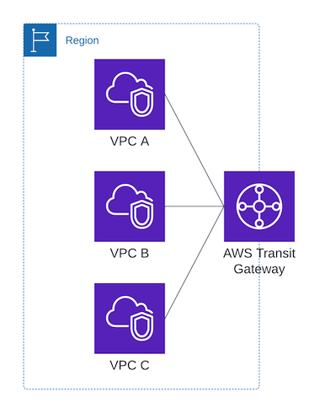Fig1:Transit Gateway

**Components of Transit Gateway:**

* **Transit Gateway :** Central hub that connects multiple VPCs and on-premises networks.
* **Attachments :** Connection between Transit Gateway and vcp’s.
* **Route Tables :** Specifies how traffic should be routed between them.

**Steps to connect three vpc’s to Transit Gateway :**

* Open AWS Console and then open VPC.
* Click on Create VPC and select VPC and More option.

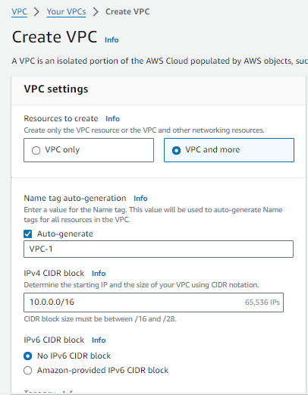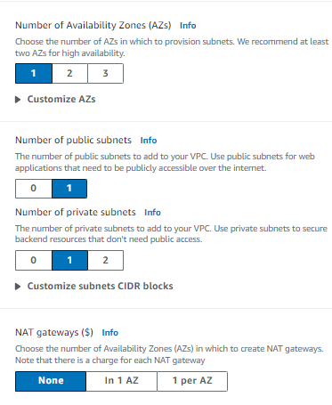

* I Was Created VPC-1 in N.Virginia (us east 1) with 2 subnets (1 public, 1 Private) & 2 Route Tables(1 Public, 1 Private) with 1 internet gateway of IP (10.0.0.0/16).
* By the same process create VPC-2 & VPC-3 with (10.11.0.0/16 & 10.12.0.0/16).

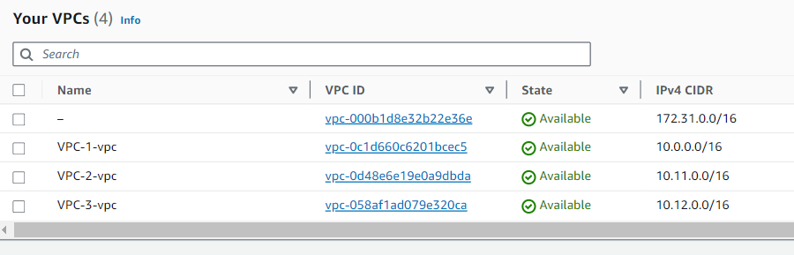

* Next Click on Transit Gateway and Create Transit Gateway with name (Transit Gateway-TG).

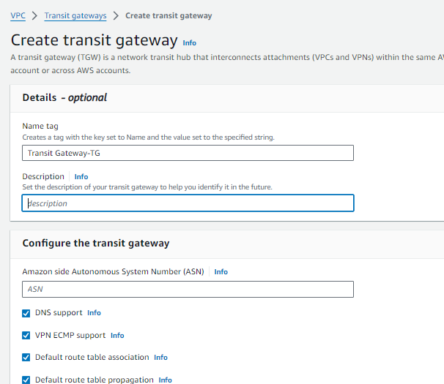

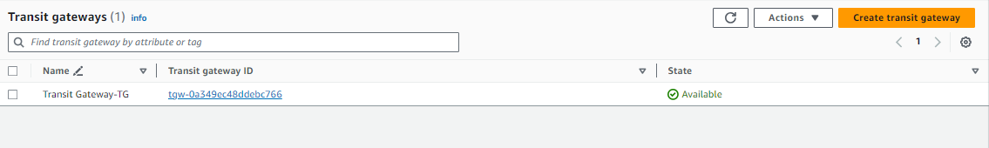

* After creating Transit Gateway click on Transit Gateway Attachments as shown below.
* Create transit gateway attachments.

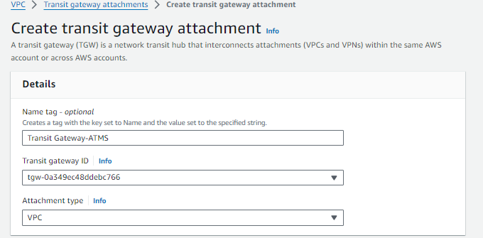

* Given name as TG-1.
* Select VPC-1 for attachmen.
* By the same process create attachments for TG-2 & TG-3 as Follow VPC-2 & VPC-3.

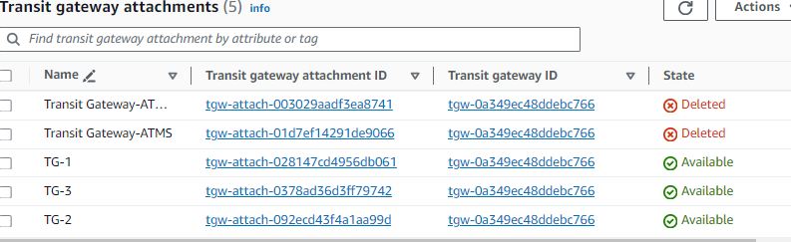

* Next go to route tables and click on VPC-1.
* Click on Add Routes and add IP’s of VPC-2 & VPC-3.

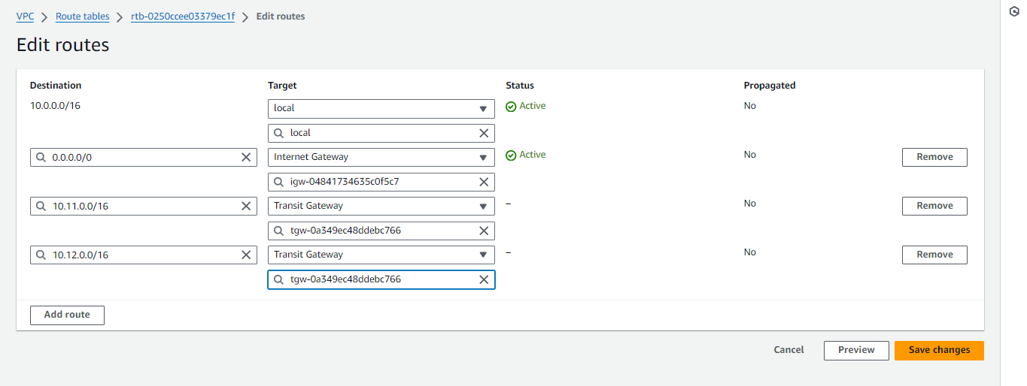

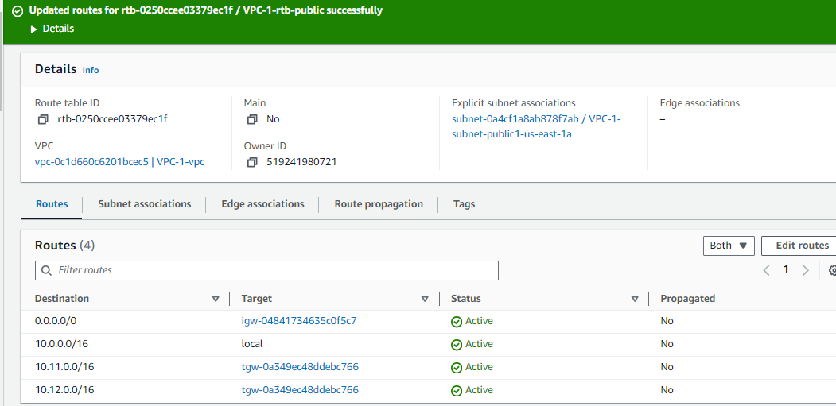

* By configuring Route Tables Next we need to create 3 Instances for VPC-1, VPC-2 &VPC-3.
* Click on EC-2 instance. Then click on create instance.
* Give instance name as server-1 and select OS & Create Key Pair.
* Create Security Group & Add rules for SSH ans HTTP as follows 22 & 80 port numbers.
* By the same process create instances for VPC-2 & VPC-3 with names as Server-2 & Server-3.

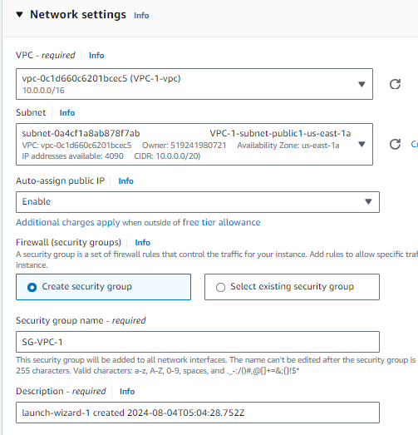

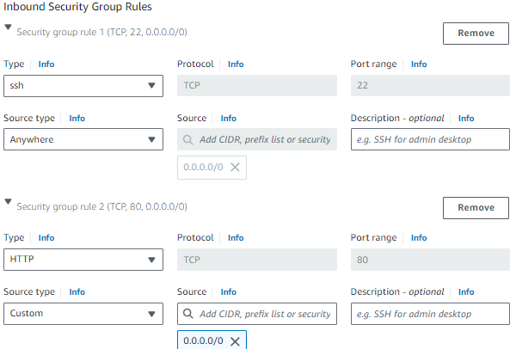

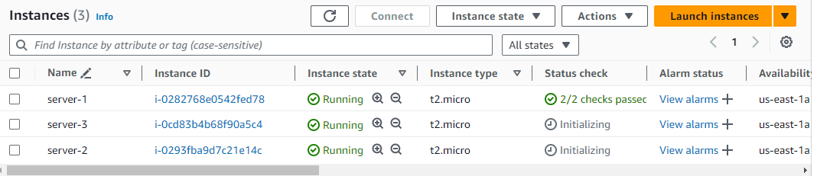

* After succefull creation of instances connect to instances and install nginx and create an .html file for our recognization.
* By the same process we need to do in 3 servers.
* First connect to the server 1 in git bash and type sudo -i for the root user.
* And then type yum update -y && yum install nginx -y && cd /usr/share/nginx/html in git bash.
* Remove index.html file and then create index.html file and insert data to the file as “This server is from VPC-1”.
* By the same do in server-2 and server-3.

**Output From Server-1 :**

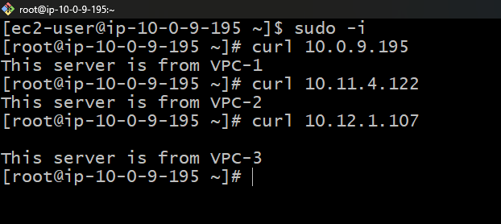

**Output From Server-2 :**

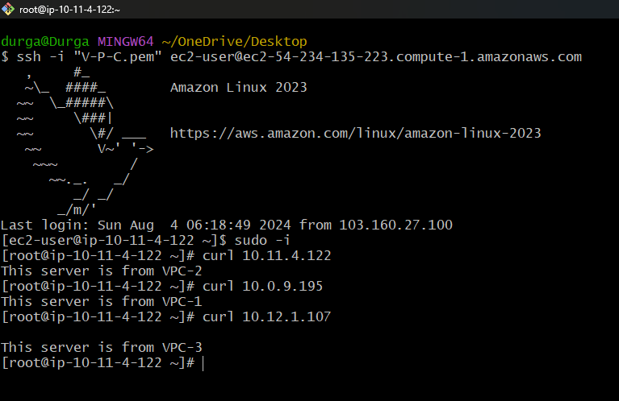

**Output From Server-3 :**

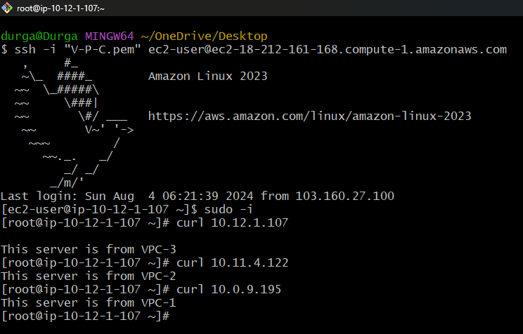

**Problems with Transit Vpc:**

* Instance Based.
* Additional EC2 Cost.
* Software Licensing Cost.
* Availability Issues.
* Bandwidth Limitations of EC2.

**Conclusion :**

AWS Transit Gateway simplifies cloud network architectures by acting as a hub to interconnect your VPCs, VPNs, and data centers. It eliminates complex mesh topologies and provides easy scalability, centralized management, and secure network segmentation. As your cloud footprint grows, Transit Gateway is key to maintaining a simple, efficient, and secure network topology.

Bandla Durgasankar

[durgasankarbandla99@gmail.com](mailto:durgasankarbandla99@gmail.com)

9652650042

Batch No : 127